22.09.23
29.09.23
10900122088
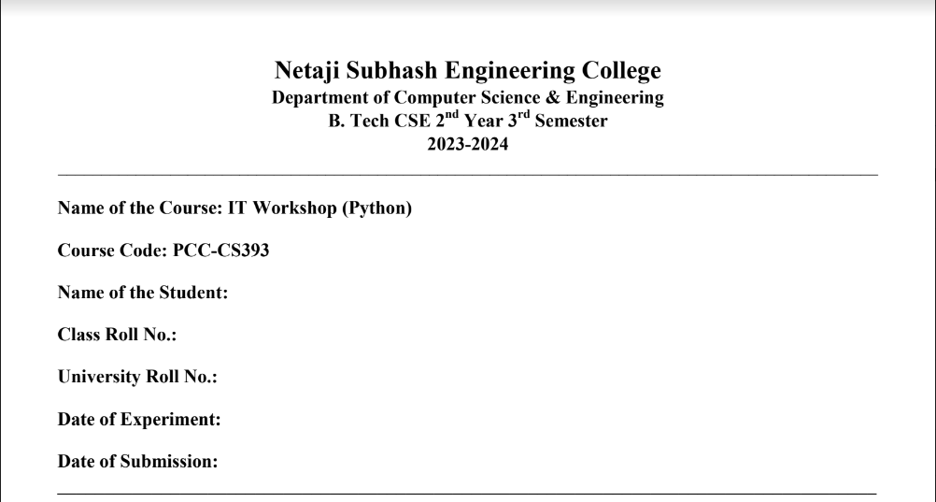
Assignment No. : Day8_01
Daksh Singh Rathore
87

Problem Statement: Create a module to check if a passed string is a palindrome or not. Write a program to find whether a string is a palindrome or not using this module.

Python Code:

def palindrome(s):
for i in range(0,len(s)//2):
if s[i]!=s[-i-1]:
return False
return True

import palin
st="wow"
if palin.palindrome(st):
print("Palindrome")
else:
print("Not palindrome")

Sample Output: Palindrome

--------------------------------------------------------x--------------------------------------------------------
Assignment No. : Day8_02

Problem Statement: Create a module to check whether a number is a prime or not. Write a program to find the prime number between two limits using this module.

Python Code:

from prime import is_prime as p

start = int(input("Enter the start of the range: "))
end = int(input("Enter the end of the range: "))

prime_numbers = [i for i in range(start, end+1) if p(i)]
print(f"Prime numbers between {start} and {end} are {prime_numbers}")

Sample Output:

Enter the start of the range:21
Enter the end of the range: 37
Prime numbers between 21 and 37 are 23,29,31,37

---------------------------------------------------------x--------------------------------------------------------

Assignment No. : Day8_03

Problem Statement: Create a module to find the factorial of a number and import the module from the main program to find the factorial of a given number.

Python Code:

from factorial import factorial as f

n = int(input("Enter a number: "))
print(f"The factorial of {n} is {f(n)}")

Sample Output:

Enter a number: 6
The factorial of 6 is 720

---------------------------------------------------------x--------------------------------------------------------

Assignment No. : Day8_04

Problem Statement: Write a program to find the mean, median, and standard deviation of a list of random numbers between 1 and 10.

Python Code:

import random, math
numbers = [random.randint(1, 10) for i in range(10)]
mean = sum(numbers) / len(numbers)
numbers.sort()
median = numbers[len(numbers)//2] if len(numbers) % 2 != 0 else sum(numbers[len(numbers)//2-1:len(numbers)//2+1]) / 2
std_dev = math.sqrt(sum((n - mean) ** 2 for n in numbers) / len(numbers))
print(f"Numbers: {numbers}\nMean: {mean}\nMedian: {median}\nStandard Deviation: {std_dev}")

Sample Output:

Numbers: [1, 3, 3, 3, 4, 4, 7, 8, 9, 9]
Mean: 5.1
Median: 4.0
Standard Deviation: 2.7367864366808017
---------------------------------------------------------x--------------------------------------------------------

Assignment No. : Day8_05

Problem Statement: Write a program to shuffle elements of a list of random numbers between given ranges.

Python Code:

import random

start = int(input("Enter the start of the range: "))
end = int(input("Enter the end of the range: "))
size = int(input("Enter the size of the list: "))

# numbers = [random.randint(start, end) for _ in range(size)]

numbers = []
for _ in range(size):
numbers.append(random.randint(start, end))

print(f"Original list: {numbers}")

random.shuffle(numbers)

print(f"Shuffled list: {numbers}")

Sample Output:

Enter the start of the range: 17
Enter the end of the range: 89
Enter the size of the list: 7

Original list:[19,23,37,29,54,72,63]
Shuffled list: [23,63,19,54,29,37,72]

--------------------------------------------------------x--------------------------------------------------------

Assignment No. : Day8_06

Problem Statement: Write a program to create a list of random numbers using list comprehension.

Python Code:

import random

start = int(input("Enter the start of the range: "))
end = int(input("Enter the end of the range: "))
size = int(input("Enter the size of the list: "))

numbers = [random.randint(start, end) for _ in range(size)]

print(f"List of random numbers: {numbers}")

Sample Output:

Enter the start of the range: 17
Enter the end of the range: 89
Enter the size of the list: 7

List of random numbers:[19,23,37,29,54,72,63]

---------------------------------------------------------x--------------------------------------------------------

